

Ambleside AC proudly presents

**Todd Crag Junior Fell Races: FRA Champs opener**

**Sunday 24th March 2018 from Rothay Park, Ambleside**

All junior races register from 11am (no earlier) at Ambleside Parish Centre LA22 9DH (beside Ambleside Primary School, Ambleside Parish Church, and Rothay Park). To walk to the Parish Centre, walk down Vicarage Road beside the Walnut Fish and Chip Shop, near Zeffirellis Restaurant.

**NO PARKING** at the Parish Centre. Please do not try to drive to the Parish Centre for drop-off - very limited access and turn-around space. Please use the main car-parks in Ambleside. (Disabled parking available for blue badge holders)

**TOILETS** in the Parish Centre and at the gates of Rothay Park.

**Refreshments** for sale in the Parish Centre, including hot soup, drinks and cakes.

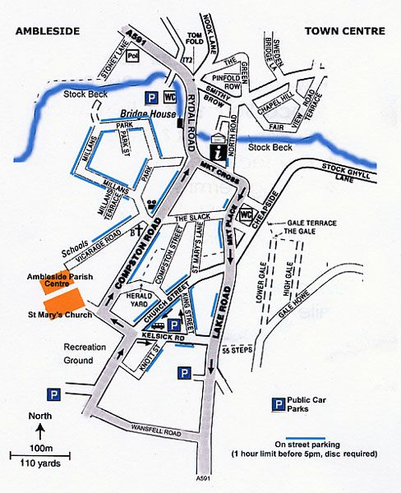

**ROTHAY PARK**

**here!**

***Access on foot from Vicarage Road and the Parish Centre.***



Cost £2 per runner. All races start and finish in Rothay Park, 2 minutes walk from registration (access on foot from Vicarage Park). Parish Centre is beside Ambleside Primary School and the Parish Church.

Prize-giving after the final race, approx. 3.45pm, at the Parish Centre.

Prizes for first 3 in each age group (U9; U11; U13; U15; U17; U19)

Races run in accordance with FRA guidelines. Min age 6 on the day. Race age categories determined by age on 31st December 2018. Please expect to carry kit (waterproofs, hat and gloves).

**Start times (after the first race) are approximate,** because they are dependent on the return of runners in previous races. They will not set off before the times stated, but could possibly be later.

**Under 9s Race – start 1pm** (minimum age 6 years on the day) from Rothay Park, past Brow Head (steep tarmac and then track) to lower gate and return.

**Under 11s Race – start approx. 1.15pm** from Rothay Park, onto the fell over the wall stile at Brow Head, climb towards Todd Crag (East of Lily Tarn) and turn below the rocky section of path.

**Under 13s Race – start approx. 1.40pm** as U11s and continue, to turn at the first cairn of Todd Crag (East of Lily Tarn - GR 367041) and return including a loop through the bracken to avoid descending the rocky section.

**Under 15s Race – start approx. 2.10pm** as U13s, and from the cairn continue to a lap of Lily Tarn (via GR 367041) and return including a loop through the bracken to avoid descending the rocky section.

**Under 17s - start approx 2.40pm** following the same route as U15s, and from Lily Tarn continue towards Loughrigg main path. At the U17/19 split go to the right along the fence, crossing on a stile and continuing beside the wall to join the Loughrigg main path by the top gate, and return to Ambleside on the main path.

**Under 19s – staggered start 10 minutes after U17s approx. 2.50pm** following the same route as U17s, continuing through the gate at the U17/19 split to keep left and join the Loughrigg main path by a little stream, and return to Ambleside on the main path.